**5-Stage Pipeline MIPS report**

**Introduction:**

In this project we designed a 32-bit MIPS pipeline processor in Verilog which is capable of executing the following commands: add, addu, addi, addiu, sub, subu, and, or, xor, xnor, andi, ori, xori, slt, sltu, slti, sltiu, lw, sw, lui, j, bne, beq, mult, multu, mflo, mfhi.

The project’s simulation is done using ModelSim.

**Illustration of instructions:**

**R-type instructions**

When the machine code goes into decode stage from fetch stage, the corresponding value store in register rs and rt, which represented by 5 bits address is read from the register file. The 5 bits address of rd and the two numbers in rs and rt then propagate to the execution stage, where according to the alu_op given by the controller, ALU will operate on the two numbers from rs and rt. The output and the rd address will propagate through the remaining pipeline, and the output is eventually written back to the position in the register file with address rd.

**add addu**

They are R-type instructions. Performs addition in ALU. Two instructions do the same operation on the hardware, because we do not need to consider overflow errors.

**sub subu**

They are R-type instructions. Performs subtraction in ALU. ALU will make the second into its 2s-complement. Two instructions do the same operation on the hardware, because we do not need to consider overflow errors.

**and or xor xnor**

They are R-type instructions. They do exactly what their names tells in ALU. All the operations are bitwise operations.

**slt sltu**

They are R-type instructions. Slt store 1 to rd, if rs is less than rt. Slt is achieved in ALU by subtraction value stored in rs by value stored in rt and output the sign bit. Sltu is achieve by unsigned comparison of the two value.

**mult multu**

They are R-type instructions. Performs multiplication in execution stage. Two instructions do the same operation on the hardware, because we do not need to consider overflow errors. Pipeline is stalled for 64 cycles, because the serial multiplier takes 64 cycles to run.

**mflo mfhi**

Instruction mflo and mfhi moves value stored in lo and hi register in the multiplier to rd. The output is selected by a mux in the execution stage.

**I-type instructions**

The 16 bits of immediate is sign extended or zero extended or shift left by 2 bits in the decode stage depending on the operation. In the execution stage the number read from rs is operated with the extended or shifted immediate. The operation depends on the function used. The result propagates through the rest of pipeline and is stored back to rt. (except memory instructions and branching instructions)

**addi addiu**

These two are I-type instructions. They do the same thing on the hardware level, because we do not consider the overflow error that may occur when using addi. The immediate is sign extended at the decode stage. At the execution stage the extended immediate is added to the value stored in rs. The result propagates through the rest of pipeline and is stored back to rt.

**andi ori xori**

They are I-type instructions. They do exactly what their names tells in ALU. All the operations are bitwise operations. Immediate is zero extended for all these operations.

**slti sltiu**

They are I-type instructions. Both instructions have their immediate sign extended in the decode stage. Slt store 1 to rd, if rs is less than the extended immediate. Slt is achieved in ALU by subtraction value stored in rs by the extended immediate and output the sign bit. Sltu is achieve by unsigned comparison of the two value.

**lw**

This is I-type instruction. Immediate is sign extended in the decode stage, and it is then added with the value read from rs in execution stage. The output in execution stage becomes the memory address in memory stage. The value read from memory is then written into register file with address given by rt, which is carried by pipeline

**sw**

This is I-type instruction. Immediate is sign extended in the decode stage, and it is then added with the value read from rs in execution stage. The output in execution stage becomes the memory address in memory stage. The value read from the rt in decode stage, is steered by mux in the execution stage and directly feed into writedata in memory stage.

**bne beq**

Instruction bne and beq have the value rs and rt compared directly at decode stage. The immediate is also shifted left 2 bits at decode stage. Bne will branch if two numbers do not equal and beq will branch is two numbers do equal. Data not yet went through the pipeline is forwarded to decode stage. If branch condition is reached PC will be set to PC+4+imm<<2.

**lui**

Instruction lui has the immediate shift left by 16 bits at decode stage. Then the shifted immediate and rt propagate through the pipeline. The value is stored into register file at address rd.

**J-type instruction j**

The 26 bits address is shifted left by 2 bits and combined with bit 31 to 28 of PC. It is all done in the decode stage.

**Design methodology:**

We used 5 stage pipeline MIPS design on the text book. We added to the text book design serial multiplier to the execution stage. Start_mult and mult_sign signal is also added to the control unit to control the multiplier. We added a zero extend unit and a left shift 16 bits unit to the decode stage, and se_ze signal to the control unit to steer a mux in decode stage to choose between zero extend and sign extend. eq_ne signal is also added to the controller to steer a mux added to the comparator output, which choose between the output and the inverse of the output. A jump circuit with left shift 2 bits is also added to decode stage and pcsrcD is change to a 2 bits signal which dives a 3 inputs mux. Hazard unit is added with some stalling logic which waits 64 cycles when the multiplication is performed.

**Step1:** Initialize a project file in Modelsim software.

**Step2:** Create a new source and name it "ALU".

**Code:**

module ALU (input [31:0] in1, in2,

input [3:0] func,

output reg [31:0] aluout);

wire [31:0] in2_muxout;

wire [31:0] sum;

wire cout;

wire sltu;

assign in2_muxout = (func[3]) ? ~in2 : in2; //invert in2

assign {cout, sum} = func[3] + in1 + in2_muxout; //adder

assign sltu = (in1 < in2_muxout) ? 1'b1 : 1'b0; //sltu

always @(*) begin

case(func[2:0])

3'b000 : aluout = in1 & in2_muxout; //and

3'b001 : aluout = in1 | in2_muxout; //or

3'b010 : aluout = in1 ^ in2_muxout; //xor

3'b011 : aluout = in1 ~^ in2_muxout; //xnor

3'b100 : aluout = sum; //add, addu, sub, subu

3'b101 : aluout = {31'b0, sum[31]}; //slt

3'b110 : aluout = {31'b0, sltu}; //sltu

default : aluout = 32'hxxxxxxxx;

endcase

end

endmodule

**Test bench:**

`timescale 1ns / 1ps

module ALU_tb;

reg [31:0] in1, in2;

reg [3:0] func;

wire [31:0] aluout;

ALU dut(in1, in2, func, aluout);

initial begin

in1 = 32'hffff_0000;

in2 = 32'hff00_ff00;

func = 4'b0000; #10 //and, return FF00_0000

func = 4'b0001; #10 //or, return FFFF_FF00

func = 4'b0010; #10 //xor, return 00FF_FF00

func = 4'b0011; #10 //xnor, return FF00_00FF

in1 = 78375;

in2 = 42596;

func = 4'b0100; #10 //add, addu, 78375 + 42596 = 120971 = 0x1D88B

func = 4'b1100; #10 //sub, subu, 78375 - 42596 = 35779 = 0x8BC3

in1 = 32'hffff_ffff; //-1

in2 = 32'h0000_000f; //15

func = 4'b1101; #10 //slt, -1 < 15, return 1

func = 4'b0110; #10 //sltu, 2^32 - 1 > 15, return 0

$stop;

end

endmodule

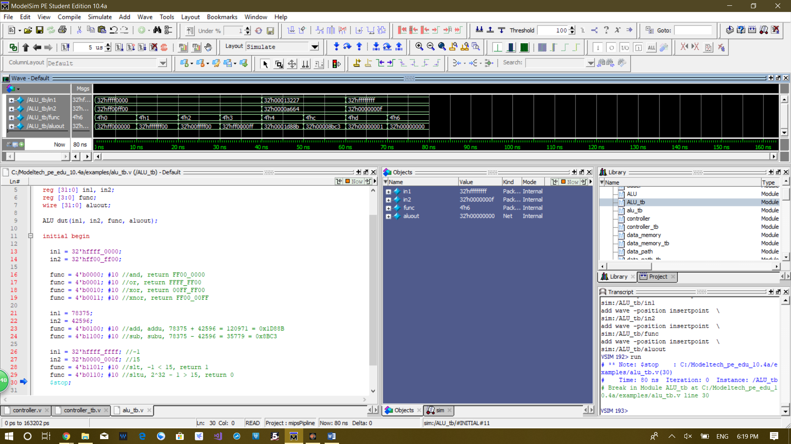**Waveform:**

10 ns per test

Tests:

1. **and**, in1 = 0xFFFF_0000, in2 = 0x0000_FF00, return FF00_0000

2. **or**, in1 = 0xFFFF_0000, in2 = 0x0000_FF00, return FFFF_FF00

3. **xor**, in1 = 0xFFFF_0000, in2 = 0x0000_FF00, return 00FF_FF00

4. **xnor**, in1 = 0xFFFF_0000, in2 = 0x0000_FF00, return FF00_00FF

5. **add, addu**, 78375 + 42596 = 120971 = 0x1D88B

6. **sub, subu**, 78375 - 42596 = 35779 = 0x8BC3

7. **slt**, in1 = -1, in2 = 15, -1 < 15, return 1

8. **sltu**, in1 = -1, in2 = 15, 2^32 - 1 > 15, return 0

**Step3:** Create a new source and name it data_memory.

**Code:**

module data_memory(input clk, write,

input [31:0] address,

input [31:0] write_data,

output reg [31:0] read_data);

reg [31:0] ram [0:63]; //64 words memory

always @(negedge clk) begin

if(write)

ram[address[31:2]] <= write_data; //write data

else

read_data <= ram[address[31:2]]; //write data

end

endmodule

**Test bench:**

`timescale 1ns / 1ps

module data_memory_tb;

reg clk = 1;

reg write = 1; //initially write to memory

reg [31:0] address;

reg [31:0] write_data;

wire [31:0] read_data;

data_memory dut (clk, write,

address,

write_data,

read_data);

task display; //task to make the clock tick

begin

#5; clk = ~clk;

#5; clk = ~clk;

end

endtask

initial begin

address = 0;

write_data = 32'hffff_ffff;

display; //write 0xFFFF_FFFF to address 0

address = 4;

write_data = 32'h0fff_ffff;

display; //write 0x0FFF_FFFF to address 4

address = 8;

write_data = 32'h00ff_ffff;

display; //write 0x00FF_FFFF to address 8

address = 12;

write_data = 32'h000f_ffff;

display; //write 0x000F_FFFF to address 12

write = 0;

address = 12;

write_data = 32'h0000_ffff;

display; //try to write 0x0000_FFFF to address 12 when write = 0

address = 0;

display; //read from address 0

address = 4;

display; //read from address 4

address = 8;

display; //read from address 8

address = 12;

display; //read from address 12

$stop;

end

endmodule

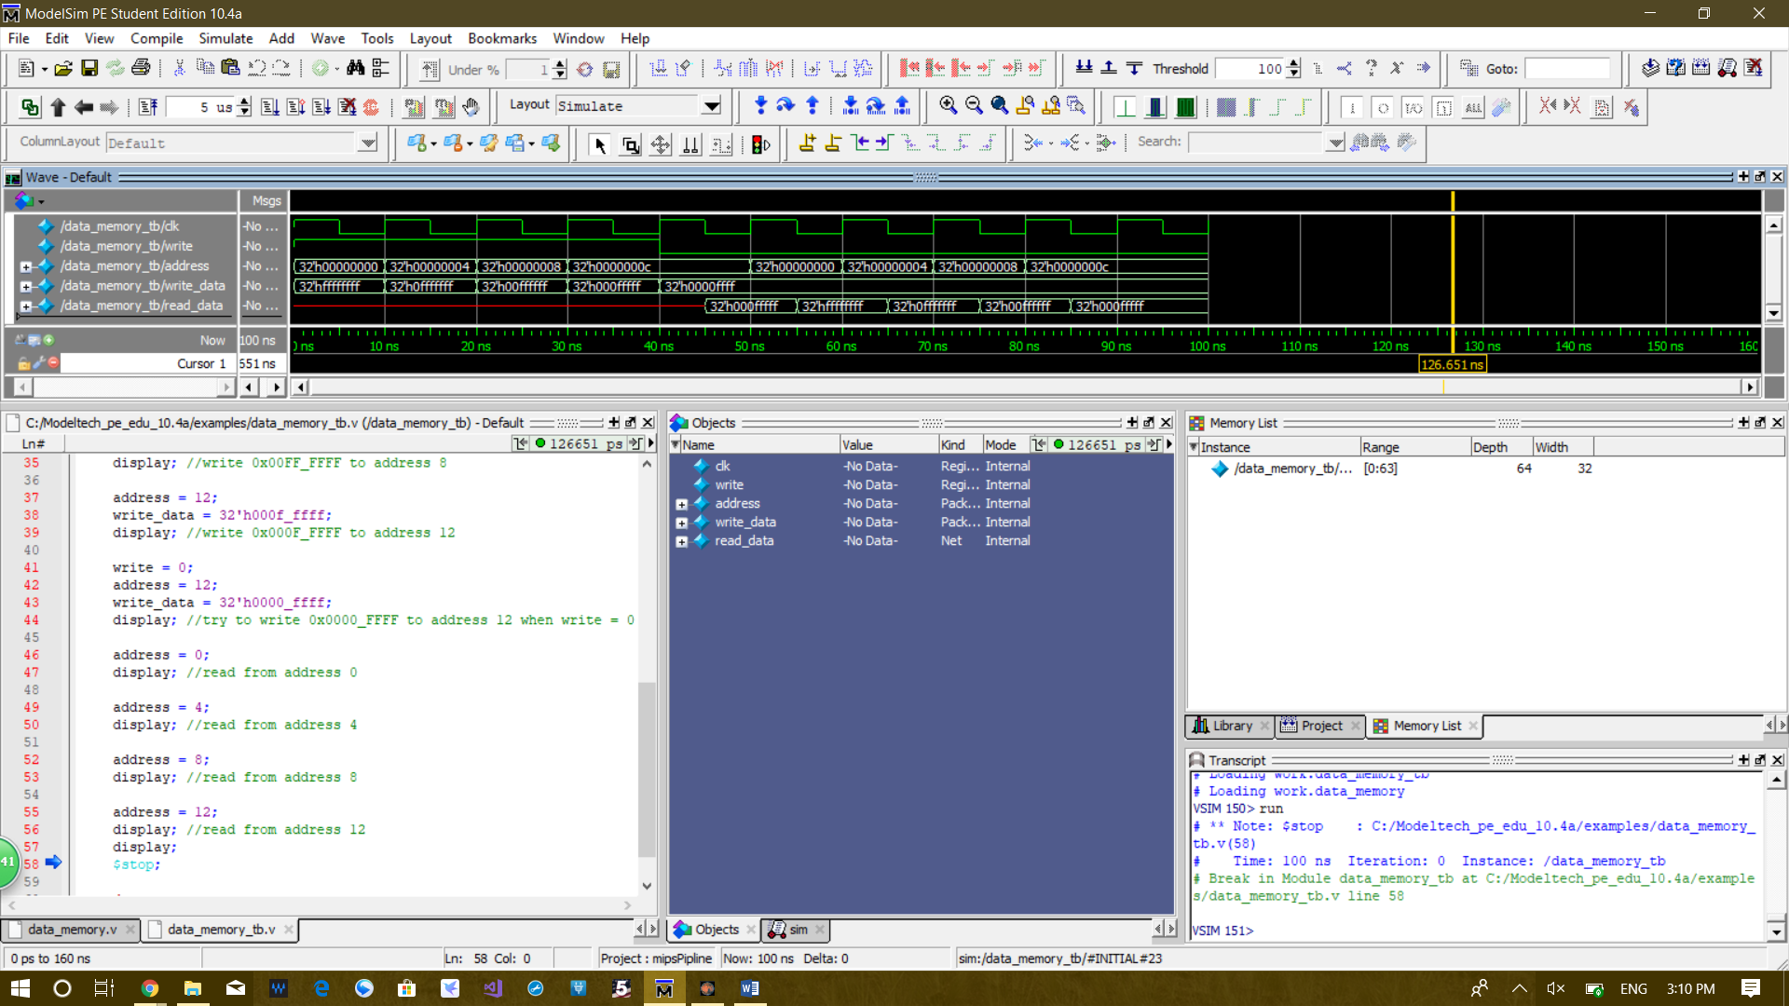**Waveform:**

10 ns per test

This data memory is lowing edge read and write.

Tests:

1. write 0xFFFF_FFFF to address 0

2. write 0x0FFF_FFFF to address 4

3. write 0x00FF_FFFF to address 8

4. write 0x000F_FFFF to address 12

5. try to write 0x0000_FFFF to address 12 when write = 0, correctly reads 0x000F_FFFF from last cycle

6. read from address 0, correctly reads 0xFFFF_FFFF

7. read from address 4, correctly reads 0x0FFF_FFFF

8. read from address 8, correctly reads 0x00FF_FFFF

9. read from address 12, correctly reads 0x000F_FFFF

**Step4:** Design instruction memory and name it inst_memory.

**Code:**

module inst_memory(input [31:0] address,

output [31:0] read_data);

reg [31:0] ram [0:127]; //memory with 128 32-bits words

initial

$readmemh("dotProduct.mem", ram); //load machine code

assign read_data = ram[address[31:2]]; //read from memory

endmodule

**Test bench:**

`timescale 1ns / 1ps

module inst_memory_tb;

reg [31:0] address = 0;

wire [31:0] read_data;

integer i;

inst_memory dut (address, read_data);

initial begin

i = 1; #10 //read in total 15 lines of machine code, i indicates the line number

for(i = 2; i <= 15 ; i = i + 1) begin

address = address + 4; #10;

end

$stop;

end

endmodule

**Waveform:**

10 ns per test, i signal counts the line number

This test bench loads first 15 lines of machine code from dotProduct.mem

The first 15 lines of code from dotProduct.mem:

1 2009001C

2 200AFF10

3 012A0018

4 00006012

5 2009006E

6 200A005B

7 012A0018

8 00005812

9 018B6020

10 2009FFD7

11 200AFF9B

12 012A0018

13 00005812

14 018B6020

15 20090017

**Step5:** Create a new source, name it reg_file.

**Code:**

module reg_file(input clk, reset, write,

input [4:0] pr1, pr2,

input [4:0] wr,

input [31:0] wd,

output [31:0] rd1, rd2);

reg [31:0] rf [0:31]; //32 registers

integer i;

always @(negedge clk) begin

if(reset) begin

for(i = 0; i < 32; i = i + 1) //reset all 32 registers

rf[i] <= 32'd0;

end

else if(write)

rf[wr] <= wd; //write data to register

end

assign rd1 = (pr1 != 0) ? rf[pr1] : 32'd0; //read from register with address pr1, $zero reads 0

assign rd2 = (pr2 != 0) ? rf[pr2] : 32'd0; //read from register with address pr2, $zero reads 0

endmodule

**Test bench:**

`timescale 1ns / 1ps

module reg_file_tb;

reg clk = 1, reset = 1, write; //reset is high at the begining

reg [4:0] pr1 = 1, pr2 = 2; //set register file to read #1 and #2 register at start

reg [4:0] wr;

reg [31:0] wd;

wire [31:0] rd1, rd2;

reg_file dut (clk, reset, write,

pr1, pr2,

wr,

wd,

rd1, rd2);

task display; //task to make the clock tick

begin

#5; clk = ~clk;

#5; clk = ~clk;

end

endtask

initial begin

display; //reset the register file

reset = 0;

write = 1;

wr = 1;

wd = 32'hffff_ffff;

reset = 0;

display; //write 0xFFFF_FFFF to register #1

wr = 2;

wd = 32'h0fff_ffff;

display; //write 0x0FFF_FFFF to register #2

wr = 3;

wd = 32'h00ff_ffff;

pr1 = 3; //read from register #3

pr2 = 4; //read from register #4

display; //write 0x00FF_FFFF to register #3

wr = 4;

wd = 32'h000f_ffff;

display; //write 0x000F_FFFF to register #4

write = 0;

wd = 32'h0000_ffff;

display; //try to write 0x0000_FFFF to register #4 when write is low

$stop;

end

endmodule

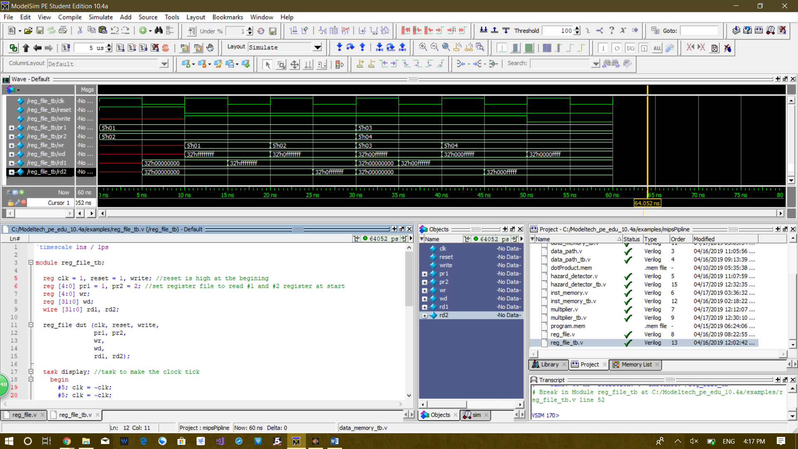**Waveform:**

10 ns per test

This register file is lowing edge write and asynchronous read

Tests:

1. reset the register file, read register #1 and #2, correctly reads 0

2. write 0xFFFF_FFFF to register #1, read register #1 and #2, correctly reads 0xFFFF_FFFF and 0 after lowering edge

3. write 0x0FFF_FFFF to register #2, read register #1 and #2, correctly reads 0xFFFF_FFFF and 0x0FFF_FFFF after lowering edge

4. write 0x00FF_FFFF to register #3, read from register #3, read from register #4, correctly reads 0 before lowering edge, and after lowering edge 0x00FF_FFFF and 0

5. write 0x000F_FFFF to register #4, read from register #3, read from register #4, correctly reads 0x00FF_FFFF and 0x000F_FFFF after lowering edge

6. try to write 0x0000_FFFF to register #4 when write is low, not successful, register #4 still reads 0x000F_FFFF

**Step6:** Designing and testing the controller.

**Code:**

module controller(input [5:0] op, func,

input equal,

output memwrite, regwrite, memtoreg, regdst, alusrc, se_ze, branch, start_mult, mult_sign,

output [3:0] alu_op,

output [1:0] out_sel, pcsrc);

wire eq_ne, jump, branch_cond;

reg [16:0] controls;

assign {memwrite, regwrite, memtoreg, regdst, alusrc, se_ze, eq_ne, branch, jump, start_mult, mult_sign, out_sel, alu_op} = controls;

assign branch_cond = (eq_ne) ? equal : ~equal; // branch condition determined by beq or bne

// pcsrc determines jump, branch, or normal pc + 4 for program counter

assign pcsrc = (branch_cond & branch) ? 2'b01 : (jump) ? 2'b10 : 2'b00;

always@(*) begin

case(op)

6'h0:

case(func)

6'h20, 6'h21: controls = 17'b01010000000_00_0100; // add / addu

6'h22, 6'h23: controls = 17'b01010000000_00_1100; // sub / subu

6'h24: controls = 17'b01010000000_00_0000; // and

6'h25: controls = 17'b01010000000_00_0001; // or

6'h26: controls = 17'b01010000000_00_0010; // xor

6'h27: controls = 17'b01010000000_00_0011; // xnor

6'h2a: controls = 17'b01010000000_00_1101; // slt

6'h2b: controls = 17'b01010000000_00_0110; // sltu

6'h18: controls = 17'b00000000011_00_0000; // mult

6'h19: controls = 17'b00000000010_00_0000; // multu

6'h10: controls = 17'b01010000000_11_0000; // mfhi

6'h12: controls = 17'b01010000000_10_0000; // mflo

default: controls = 17'b0;

endcase

6'h23: controls = 17'b01101100000_00_0100; // lw

6'h2b: controls = 17'b10001100000_00_0100; // sw

6'h4: controls = 17'b00000111000_00_0000; // beq

6'h5: controls = 17'b00000101000_00_0000; // bne

6'h8, 6'h9: controls = 17'b01001100000_00_0100; // addi / addiu

6'hc: controls = 17'b01001000000_00_0000; // andi

6'hd: controls = 17'b01001000000_00_0001; // ori

6'he: controls = 17'b01001000000_00_0010; // xori

6'ha: controls = 17'b01001100000_00_1101; // slti

6'hb: controls = 17'b01001100000_00_0110; // sltiu

6'hf: controls = 17'b01000000000_01_0000; // lui

6'h2: controls = 17'b00000000100_00_0000; // j

default: controls = 17'b0;

endcase

end

endmodule

**Test bench:**

`timescale 1ns / 1ps

module controller_tb;

reg [5:0] op, func;

reg equal;

wire memwrite, regwrite, memtoreg, regdst, alusrc, se_ze, branch, start_mult, mult_sign;

wire [3:0] alu_op;

wire [1:0] out_sel, pcsrc;

controller dut (op, func,

equal,

memwrite, regwrite, memtoreg, regdst, alusrc, se_ze, branch, start_mult, mult_sign,

alu_op,

out_sel, pcsrc);

initial begin

//signal order: memwrite, regwrite, memtoreg, regdst, alusrc, se_ze, branch, start_mult, mult_sign, alu_op, out_sel, pcsrc

op = 6'h0; //R-type instructions

func = 0'h20; #10; //add 010100000_0100_00_00

func = 0'h21; #10; //addu 010100000_0100_00_00

func = 0'h22; #10; //sub 010100000_1100_00_00

func = 0'h23; #10; //subu 010100000_1100_00_00

func = 0'h24; #10; //and 010100000_0000_00_00

func = 0'h25; #10; //or 010100000_0001_00_00

func = 0'h26; #10; //xor 010100000_0010_00_00

func = 0'h27; #10; //xnor 010100000_0011_00_00

func = 6'h2a; #10; //slt 010100000_1101_00_00

func = 6'h2b; #10; //sltu 010100000_0110_00_00

func = 6'h18; #10; //mult 000000011_0000_00_00

func = 6'h19; #10; //multu 000000010_0000_00_00

func = 6'h10; #10; //mfhi 010100000_0000_11_00

func = 6'h12; #10; //mflo 010100000_0000_10_00

//I-type instructions

func = 6'bxxxxxx;

op = 6'h23; #10; //lw 011011000_0100_00_00

op = 6'h2b; #10; //sw 100011000_0100_00_00

op = 6'h4; //beq

equal = 0; #10; // 000001100_0000_00_00

equal = 1; #10; // 000001100_0000_00_01

op = 6'h5; //bne

equal = 0; #10; // 000001100_0000_00_01

equal = 1; #10; // 000001100_0000_00_01

equal = 1'bx;

op = 6'h8; #10; //addi 010011000_0100_00_00

op = 6'h9; #10; //addiu 010011000_0100_00_00

op = 6'hc; #10; //andi 010010000_0000_00_00

op = 6'hd; #10; //ori 010010000_0001_00_00

op = 6'he; #10; //xori 010010000_0010_00_00

op = 6'ha; #10; //slti 010011000_1101_00_00

op = 6'hb; #10; //sltiu 010011000_0110_00_00

op = 6'hf; #10; //lui 010000000_0000_01_00

op = 6'h2; #10; //j 000000000_0000_00_10

$stop;

end

endmodule

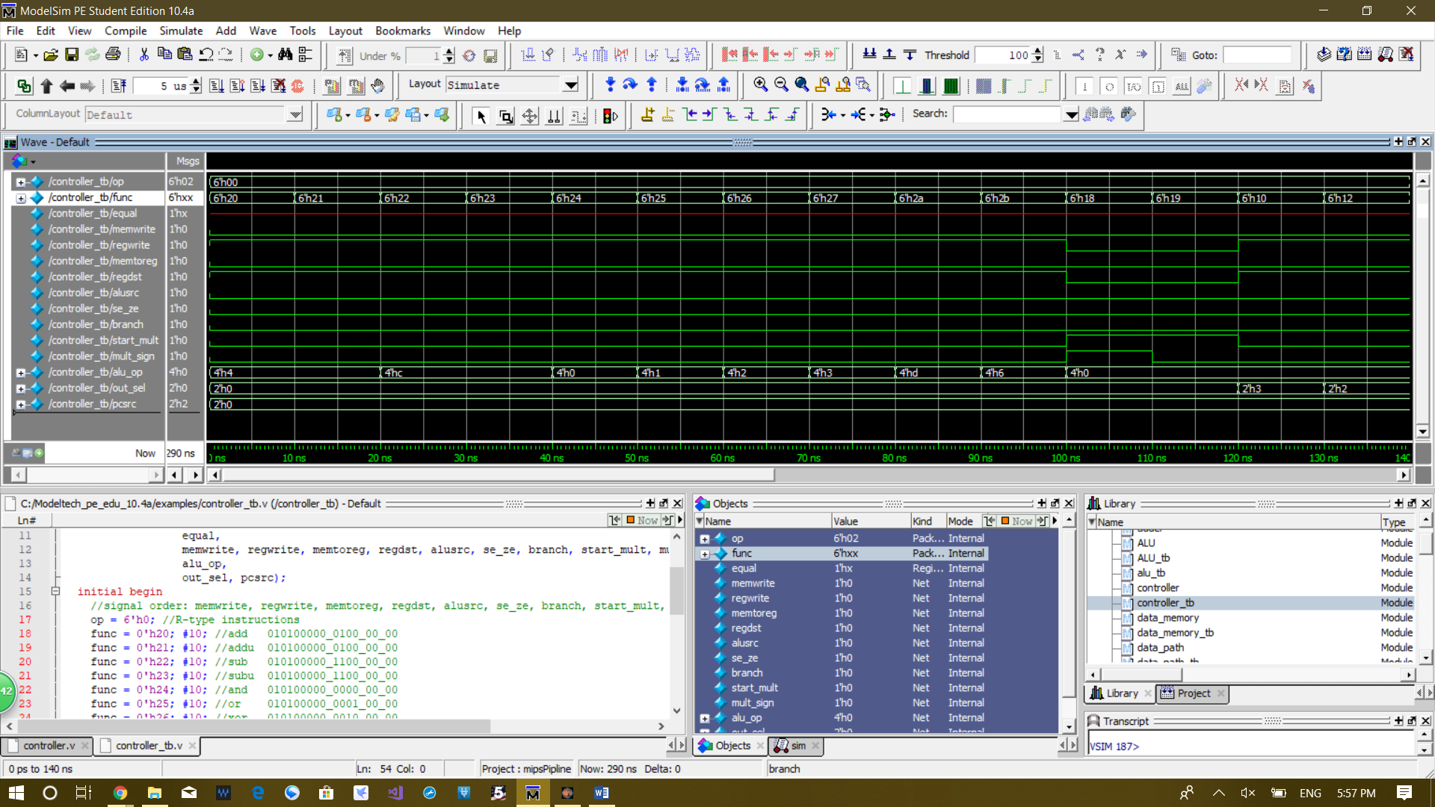**Waveform:**

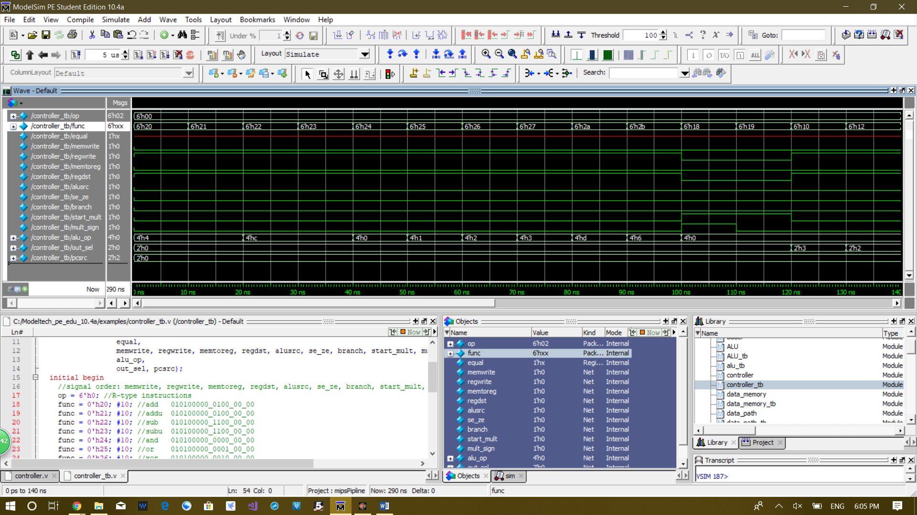

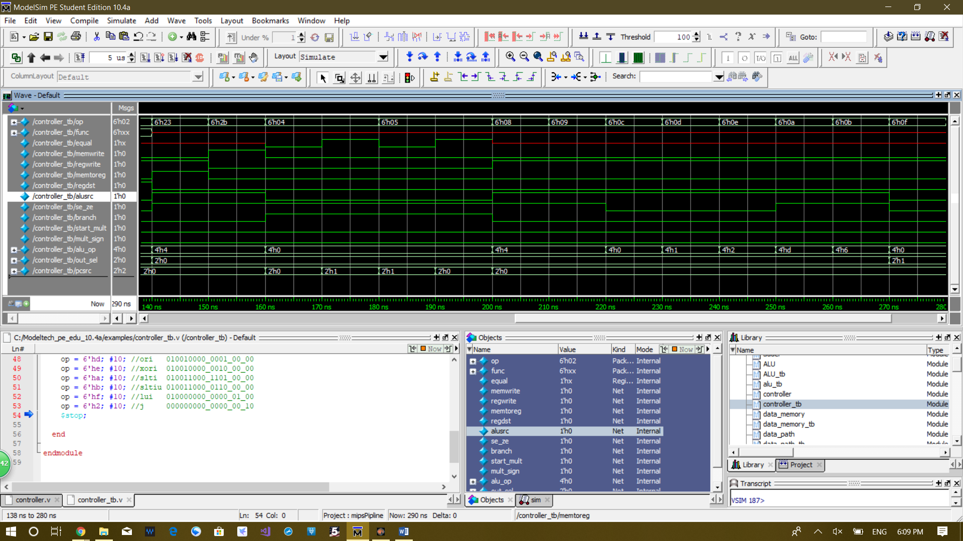



10 ns per test

Output are in the order: memwrite, regwrite, memtoreg, regdst, alusrc, se_ze, branch, start_mult, mult_sign, alu_op, out_sel, pcsrc

Tests:

1. add, expected output, 010100000_0100_00_00

2. addu, expected output, 010100000_0100_00_00

3. sub, expected output, 010100000_1100_00_00

4. subu, expected output, 010100000_1100_00_00

5. and, expected output, 010100000_0000_00_00

6. or, expected output, 010100000_0001_00_00

7. xor, expected output, 010100000_0010_00_00

8. xnor, expected output, 010100000_0011_00_00

9. slt, expected output, 010100000_1101_00_00

10. sltu, expected output, 010100000_0110_00_00

11. mult, expected output, 000000011_0000_00_00

12. multu, expected output, 000000010_0000_00_00

12. mfhi, expected output, 010100000_0000_11_00

13. mflo, expected output, 010100000_0000_10_00

14. lw, expected output, 011011000_0100_00_00

15. sw, expected output, 100011000_0100_00_00

16. beq, equal = 0, expected output, 000001100_0000_00_00

17. beq, equal = 1, expected output, 000001100_0000_00_01

18. bne, equal = 0, expected output, 000001100_0000_00_01

19. bne, equal = 1, expected output, 000001100_0000_00_01

20. addi, expected output, 010011000_0100_00_00

21. addiu, expected output, 010011000_0100_00_00

22. andi, expected output, 010010000_0000_00_00

23. ori, expected output, 010010000_0001_00_00

24. xori, expected output, 010010000_0010_00_00

25. slti, expected output, 010011000_1101_00_00

26. sltiu, expected output, 010011000_0110_00_00

27. lui, expected output, 010000000_0000_01_00

28. j, expected output, 000000000_0000_00_10

**Step7:** Design a 32-bit serial multiplier.

**Code:**

module multiplier(input clk, start, is_signed,

input [31:0] a, b,

output reg busy = 0,

output reg [63:0] s);

reg [63:0] a_temp;

reg [128:0] s_temp; //129 bits shift register to store product

reg [6:0] i = 64; //edge cycle count

always @(posedge clk) begin

if(start) begin

i <= 0;

busy <= 1;

s_temp[128:64] <= 65'b0; //reset the upper 65 bits to 0

if(is_signed) begin

a_temp[63:0] <= { {32{a[31]}}, a[31:0] }; //sign extend a to 64 bits, store to a_temp

s_temp[63:0] <= { {32{b[31]}}, b[31:0] }; //sign extend b to 64 bits, store to s_temp's lower 64 bits

end

else begin

a_temp[63:0] <= { 32'b0, a[31:0] }; //zero extend a to 64 bits, store to a_temp

s_temp[63:0] <= { 32'b0, b[31:0] }; //zero extend b to 64 bits, store to s_temp's lower 64 bits

end

end

else if(i < 64) begin

if(s_temp[0]) //add a_temp to upper 65 bits of s_temp if last digit of s_temp is 1

s_temp[128:64] = s_temp[128:64] + a_temp[63:0];

s_temp = s_temp >> 1; //left shit s_temp by 1

i = i + 1; //cycle count + 1

if(i == 64) begin

s <= s_temp[63:0]; //actual product is the lower 64 bits of s_temp

busy <= 0;

end

end

end

endmodule

**Test bench:**

`timescale 1ns / 1ps

module multiplier_tb;

reg [31:0] a = 0;

reg [31:0] b = 0;

reg clk = 0, start = 0;

reg is_signed = 0;

wire busy;

wire[63:0] s;

integer i = 0;

reg [63:0] k;

multiplier dut (clk, start, is_signed, a, b, busy, s);

task display; //task to make the clock tick

begin

#1; clk = ~clk;

#1; clk = ~clk;

end

endtask

initial begin

//87359729 * 23422 signed

a = 87359729; b = 23422; is_signed = 1;

start = 1; display; start = 0;

for (i = 1; i < 65; i = i + 1) display;

k = 87359729 * 23422; //directly multiply to check the result

//-77 * 999 signed

a = -77; b = 999; is_signed = 1;

start = 1; display; start = 0;

for (i = 1; i < 65; i = i + 1) display;

k = -77 * 999; //directly multiply to check the result

//809843053 * -328932 signed

a = 809843053; b = -328932; is_signed = 1;

start = 1; display; start = 0;

for (i = 1; i < 65; i = i + 1) display;

k = 809843053 * -328932; //directly multiply to check the result

//-2147483648 * -2147483648 signed

a = -2147483648; b = -2147483648; is_signed = 1;

start = 1; display; start = 0;

for (i = 1; i < 65; i = i + 1) display;

k = -2147483648 * -2147483648; //directly multiply to check the result

//33329255 * 45825983 unsigned

a = 33329255; b = 45825983; is_signed = 0;

start = 1; display; start = 0;

for (i = 1; i < 65; i = i + 1) display;

k = 33329255 * 45825983; //directly multiply to check the result

//0xF398_F1AB * 0xFFFF_FFFF unsigned

a = 32'hf398_f1ab; b = 32'hffff_ffff; is_signed = 0;

start = 1; display; start = 0;

for (i = 1; i < 65; i = i + 1) display;

k = 32'hf398_f1ab * 32'hffff_ffff; //directly multiply to check the result

start = 0; display; start = 0;

for (i = 1; i < 65; i = i + 1) display;

$stop;

end

endmodule

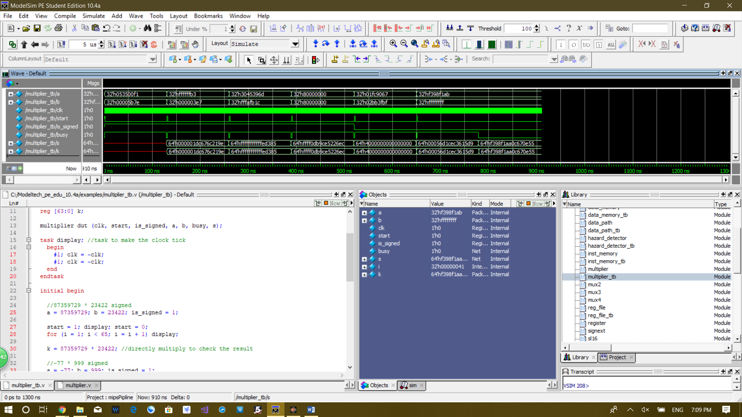**Waveform:**

1 clock cycle takes 2 ns.

It takes 65 cycles from the start signal becoming high to output becoming valid.

Signal k is generated by directly multipling the two numbers using “*” in verilog.

As you can see value of k equals the value of s for every test.

Busy is a signal used by hazard detector to know whether the multipilier finished multiplication

Tests:

1. signed, 87359729 * 23422, output becomes valid at 129 ns

2. signed, -77 * 999, output becomes valid at 259 ns

3. signed, 809843053 * -328932, output becomes valid at 389 ns

4. signed, -2147483648 * -2147483648, output becomes valid at 519 ns

5. unsigned, 33329255 * 45825983, output becomes valid at 649 ns

6. unsigned, 0xF398_F1AB * 0xFFFF_FFFF, output becomes valid at 779 ns

**Step8:** Design hazard detector to detect.

**Code:**

module hazard_detector(input branchD,

input memtoregE, regwriteE,

input memtoregM,

input regwriteW,

input start_multE, busy_multE, //let hazard unit know when mult is done

input [4:0] rsD, rtD, rsE, rtE,

input [4:0] writeregE, writeregM,

output stallF, stallD,

output flushE);

wire lwstall;

wire branchstall, bsc1, bsc2;

wire multstall;

assign multstall = start_multE | busy_multE;

assign lwstall = ((rsD == rtE) | (rtD == rtE)) & memtoregE;

assign bsc1 = ((writeregE == rsD) | (writeregE == rtD)) & regwriteE;

assign bsc2 = ((writeregM == rsD) | (writeregM == rtD)) & memtoregM;

assign branchstall = branchD & (bsc1 | bsc2);

// decode stage stall signals

assign flushE = lwstall | branchstall | multstall;

assign stallD = flushE;

assign stallF = stallD;

endmodule

**Test bench:**

`timescale 1ns / 1ps

module hazard_detector_tb;

reg branchD;

reg memtoregE, regwriteE;

reg memtoregM;

reg regwriteW;

reg start_multE, busy_multE;

reg [4:0] rsD, rtD, rsE, rtE;

reg [4:0] writeregE, writeregM;

wire stallF, stallD;

wire flushE;

hazard_detector dut (branchD,

memtoregE, regwriteE,

memtoregM,

regwriteW,

start_multE, busy_multE,

rsD, rtD, rsE, rtE,

writeregE, writeregM,

stallF, stallD,

flushE);

initial begin

//mult stall

start_multE = 0; busy_multE = 0; #10; //stallF = stallD = flushE = x

start_multE = 0; busy_multE = 1; #10; //stallF = stallD = flushE = 1

start_multE = 1; busy_multE = 0; #10; //stallF = stallD = flushE = 1

start_multE = 1'bx; busy_multE = 1'bx;

//lw stall

rsD = 12; rtD = 11; rtE = 10; memtoregE = 1; #10; //stallF = stallD = flushE = x

rsD = 10; rtD = 11; rtE = 10; memtoregE = 1; #10; //stallF = stallD = flushE = 1

rsD = 11; rtD = 10; rtE = 10; memtoregE = 1; #10; //stallF = stallD = flushE = 1

rsD = 10; rtD = 10; rtE = 10; memtoregE = 1; #10; //stallF = stallD = flushE = 1

rsD = 10; rtD = 10; rtE = 10; memtoregE = 0; #10; //stallF = stallD = flushE = x

rsD = 5'bx; rtD = 5'bx; rtE = 5'bx; memtoregE = 1'bx;

//branch stall

branchD = 1; rsD = 5; rtD = 6; writeregE = 7; regwriteE = 1; writeregM = 8; memtoregM = 1; #10; //stallF = stallD = flushE = x

branchD = 1; rsD = 5; rtD = 6; writeregE = 5; regwriteE = 1; writeregM = 7; memtoregM = 1; #10; //stallF = stallD = flushE = 1

branchD = 1; rsD = 5; rtD = 6; writeregE = 7; regwriteE = 1; writeregM = 6; memtoregM = 1; #10; //stallF = stallD = flushE = 1

branchD = 1; rsD = 5; rtD = 6; writeregE = 7; regwriteE = 1; writeregM = 6; memtoregM = 0; #10; //stallF = stallD = flushE = x

rsD = 5'bx; rtD = 5'bx; writeregE = 5'bx; regwriteE = 1'bx; writeregM = 5'bx; memtoregM = 1'bx;

$stop;

end

endmodule

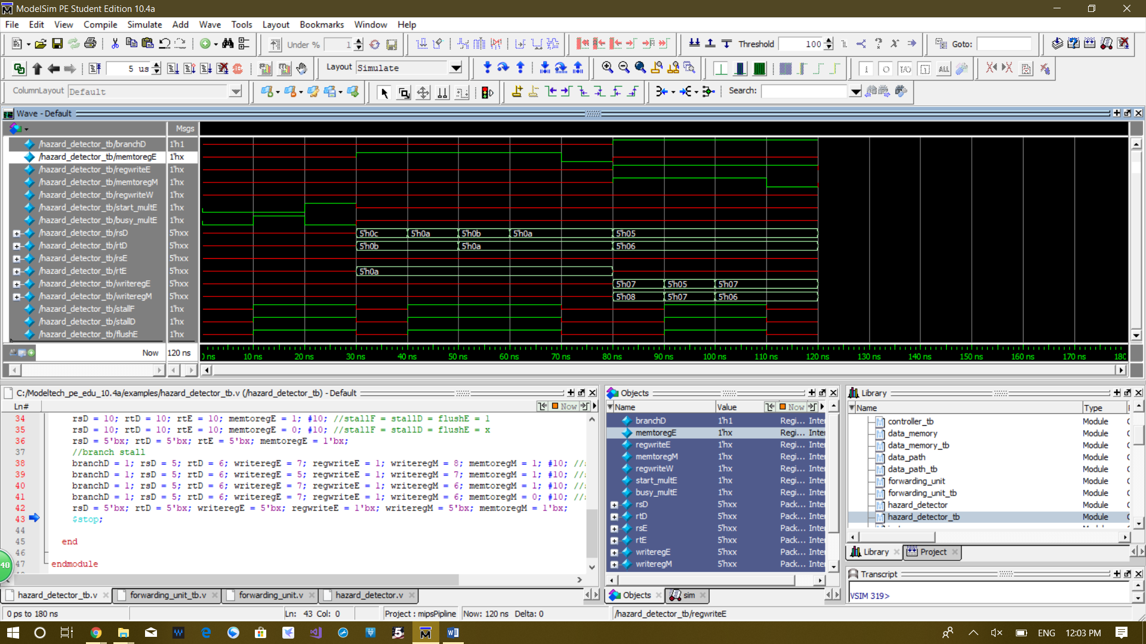**Waveform:**

10 ns per test

Busy_multE is the a input signal to the hazard detector which shows whether the multiplier is busy or not.

Tests:

1. mult stall, start_multE = 0, busy_multE = 0, expected result, stallF = stallD = flushE = x

2. mult stall, start_multE = 0, busy_multE = 1, expected result, stallF = stallD = flushE = 1

3. mult stall, start_multE = 1; busy_multE = 0, expected result, stallF = stallD = flushE = 1

4. lw stall, rsD = 12, rtD = 11, rtE = 10, memtoregE = 1, expected result, stallF = stallD = flushE = x

5. lw stall, rsD = 10, rtD = 11, rtE = 10, memtoregE = 1, expected result, stallF = stallD = flushE = 1

6. lw stall, rsD = 11, rtD = 10, rtE = 10, memtoregE = 1, expected result, stallF = stallD = flushE = 1

7. lw stall, rsD = 10, rtD = 10, rtE = 10, memtoregE = 1, expected result, stallF = stallD = flushE = 1

8. lw stall, rsD = 10, rtD = 10, rtE = 10, memtoregE = 0, expected result, stallF = stallD = flushE = x

9. branch stall, branchD = 1, rsD = 5, rtD = 6, writeregE = 7, regwriteE = 1, writeregM = 8, memtoregM = 1, expected result, stallF = stallD = flushE = x

10.branch stall, branchD = 1, rsD = 5, rtD = 6, writeregE = 5, regwriteE = 1, writeregM = 7, memtoregM = 1, expected result, stallF = stallD = flushE = 1

11. branch stall, branchD = 1, rsD = 5; rtD = 6, writeregE = 7, regwriteE = 1, writeregM = 6, memtoregM = 1, expected result, stallF = stallD = flushE = 1

12. branch stall, branchD = 1, rsD = 5, rtD = 6, writeregE = 7, regwriteE = 1, writeregM = 6, memtoregM = 0, expected result, stallF = stallD = flushE = x

**Step9:** In this step, you will design a forwarding unit.

**Code:**

module forwarding_unit(input regwriteM,

input regwriteW,

input [4:0] rsD, rtD, rsE, rtE,

input [4:0] writeregM, writeregW,

output forwardaD, forwardbD,

output reg [1:0] forwardaE, forwardbE);

assign forwardaD = (rsD != 0) & (rsD == writeregM) & regwriteM;

assign forwardbD = (rtD != 0) & (rtD == writeregM) & regwriteM;

always @(*) begin

if(rsE != 0 && rsE == writeregM && regwriteM)

forwardaE = 2'b10; // forward from memory stage

else if(rsE != 0 && rsE == writeregW && regwriteW)

forwardaE = 2'b01; // forward from write-back stage

else

forwardaE = 2'b00; // no forwarding

if(rtE != 0 && rtE == writeregM && regwriteM)

forwardbE = 2'b10;

else if(rtE != 0 && rtE == writeregW && regwriteW)

forwardbE = 2'b01;

else

forwardbE = 2'b00;

end

endmodule

**Test bench:**

`timescale 1ns / 1ps

module forwarding_unit_tb;

reg regwriteM;

reg regwriteW;

reg [4:0] rsD, rtD, rsE, rtE;

reg [4:0] writeregM, writeregW;

wire forwardaD, forwardbD;

wire [1:0] forwardaE, forwardbE;

forwarding_unit dut (regwriteM,

regwriteW,

rsD, rtD, rsE, rtE,

writeregM, writeregW,

forwardaD, forwardbD,

forwardaE, forwardbE);

initial begin

//forwardA decode stage

rsD = 0; writeregM = 0; regwriteM = 1; #10; //forwardaD = 0

rsD = 5; writeregM = 2; regwriteM = 1; #10; //forwardaD = 0

rsD = 5; writeregM = 5; regwriteM = 1; #10; //forwardaD = 1

rsD = 5; writeregM = 5; regwriteM = 0; #10; //forwardaD = 0

rsD = 5'bx; writeregM = 5'bx; regwriteM = 1'bx;

//forwardB decode stage

rtD = 0; writeregM = 0; regwriteM = 1; #10; //forwardbD = 0

rtD = 5; writeregM = 2; regwriteM = 1; #10; //forwardbD = 0

rtD = 5; writeregM = 5; regwriteM = 1; #10; //forwardbD = 1

rtD = 5; writeregM = 5; regwriteM = 0; #10; //forwardbD = 0

rtD = 5'bx; writeregM = 5'bx; regwriteM = 1'bx;

//forwardA execution stage

rsE = 5; writeregM = 5; regwriteM = 1; writeregW = 5; regwriteW = 1; #10; //forwardaE = 2'b10

rsE = 0; writeregM = 5; regwriteM = 1; writeregW = 5; regwriteW = 1; #10; //forwardaE = 2'b00

rsE = 4; writeregM = 5; regwriteM = 1; writeregW = 6; regwriteW = 1; #10; //forwardaE = 2'b00

rsE = 5; writeregM = 4; regwriteM = 1; writeregW = 5; regwriteW = 1; #10; //forwardaE = 2'b01

rsE = 5'bx; writeregM = 5'bx; regwriteM = 1'bx; writeregW = 5'bx; regwriteW = 1'bx;

//forwardB execution stage

rtE = 5; writeregM = 5; regwriteM = 1; writeregW = 5; regwriteW = 1; #10; //forwardbE = 2'b10

rtE = 0; writeregM = 5; regwriteM = 1; writeregW = 5; regwriteW = 1; #10; //forwardbE = 2'b00

rtE = 4; writeregM = 5; regwriteM = 1; writeregW = 6; regwriteW = 1; #10; //forwardbE = 2'b00

rtE = 5; writeregM = 4; regwriteM = 1; writeregW = 5; regwriteW = 1; #10; //forwardbE = 2'b01

rtE = 5'bx; writeregM = 5'bx; regwriteM = 1'bx; writeregW = 5'bx; regwriteW = 1'bx;

$stop;

end

endmodule

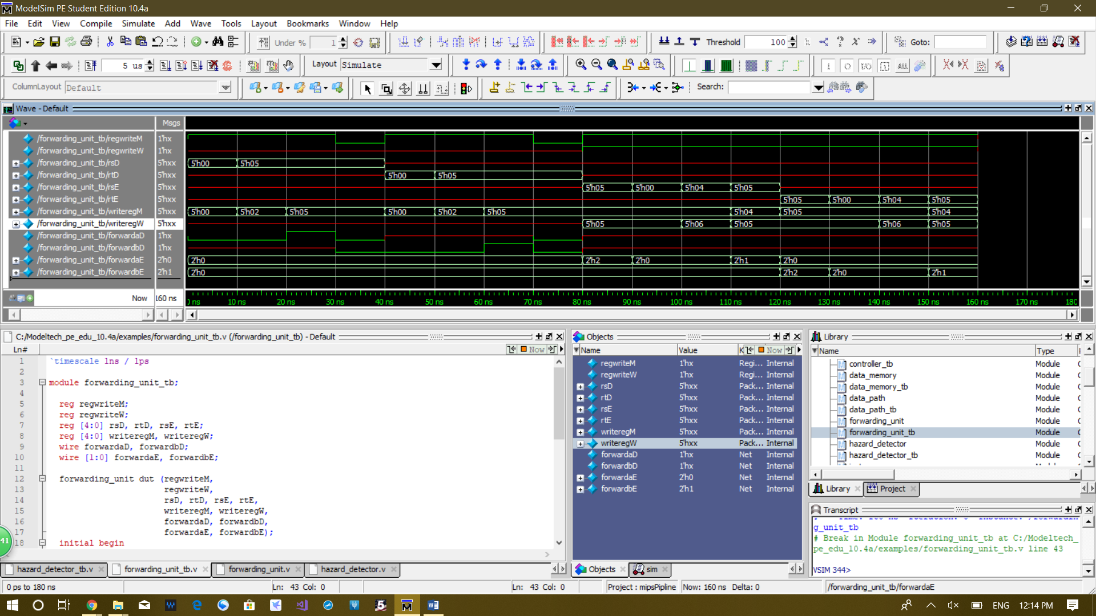**Waveform:**

10 ns per test

1. forwardA decode stage, rsD = 0, writeregM = 0, regwriteM = 1, expected result, forwardaD = 0

2. forwardA decode stage, rsD = 5, writeregM = 2, regwriteM = 1, expected result, forwardaD = 0

3. forwardA decode stage, rsD = 5, writeregM = 5, regwriteM = 1, expected result, forwardaD = 1

4. forwardA decode stage, rsD = 5, writeregM = 5, regwriteM = 0, expected result, forwardaD = 0

5. forwardB decode stage, rtD = 0; writeregM = 0; regwriteM = 1, expected result, forwardbD = 0

6. forwardB decode stage, rtD = 5; writeregM = 2; regwriteM = 1, expected result, forwardbD = 0

7. forwardB decode stage, rtD = 5, writeregM = 5, regwriteM = 1, expected result, forwardbD = 1

8. forwardB decode stage, rtD = 5, writeregM = 5, regwriteM = 0, expected result, forwardbD = 0

9. forwardA execution stage, rsE = 0, writeregM = 5, regwriteM = 1, writeregW = 5, regwriteW = 1, expected result, forwardaE = 2'b00

10. forwardA execution stage, rsE = 4, writeregM = 5, regwriteM = 1, writeregW = 6, regwriteW = 1, expected result, forwardaE = 2'b00

11. forwardA execution stage, rsE = 5; writeregM = 5, regwriteM = 1, writeregW = 5, regwriteW = 1, expected result, forwardaE = 2'b10

12. forwardA execution stage, rsE = 5, writeregM = 4, regwriteM = 1, writeregW = 5, regwriteW = 1, expected result, forwardaE = 2'b01

13. forwardB execution stage, rtE = 0, writeregM = 5, regwriteM = 1, writeregW = 5, regwriteW = 1, expected result, forwardbE = 2'b00

14. forwardB execution stage, rtE = 4, writeregM = 5, regwriteM = 1, writeregW = 6, regwriteW = 1, expected result, forwardbE = 2'b00

15. forwardB execution stage, rtE = 5, writeregM = 5, regwriteM = 1, writeregW = 5, regwriteW = 1, expected result, forwardbE = 2'b10

16. forwardB execution stage, rtE = 5, writeregM = 4, regwriteM = 1, writeregW = 5, regwriteW = 1, expected result, forwardbE = 2'b01

**Step10:** All building blocks in previous steps placed in one figure.

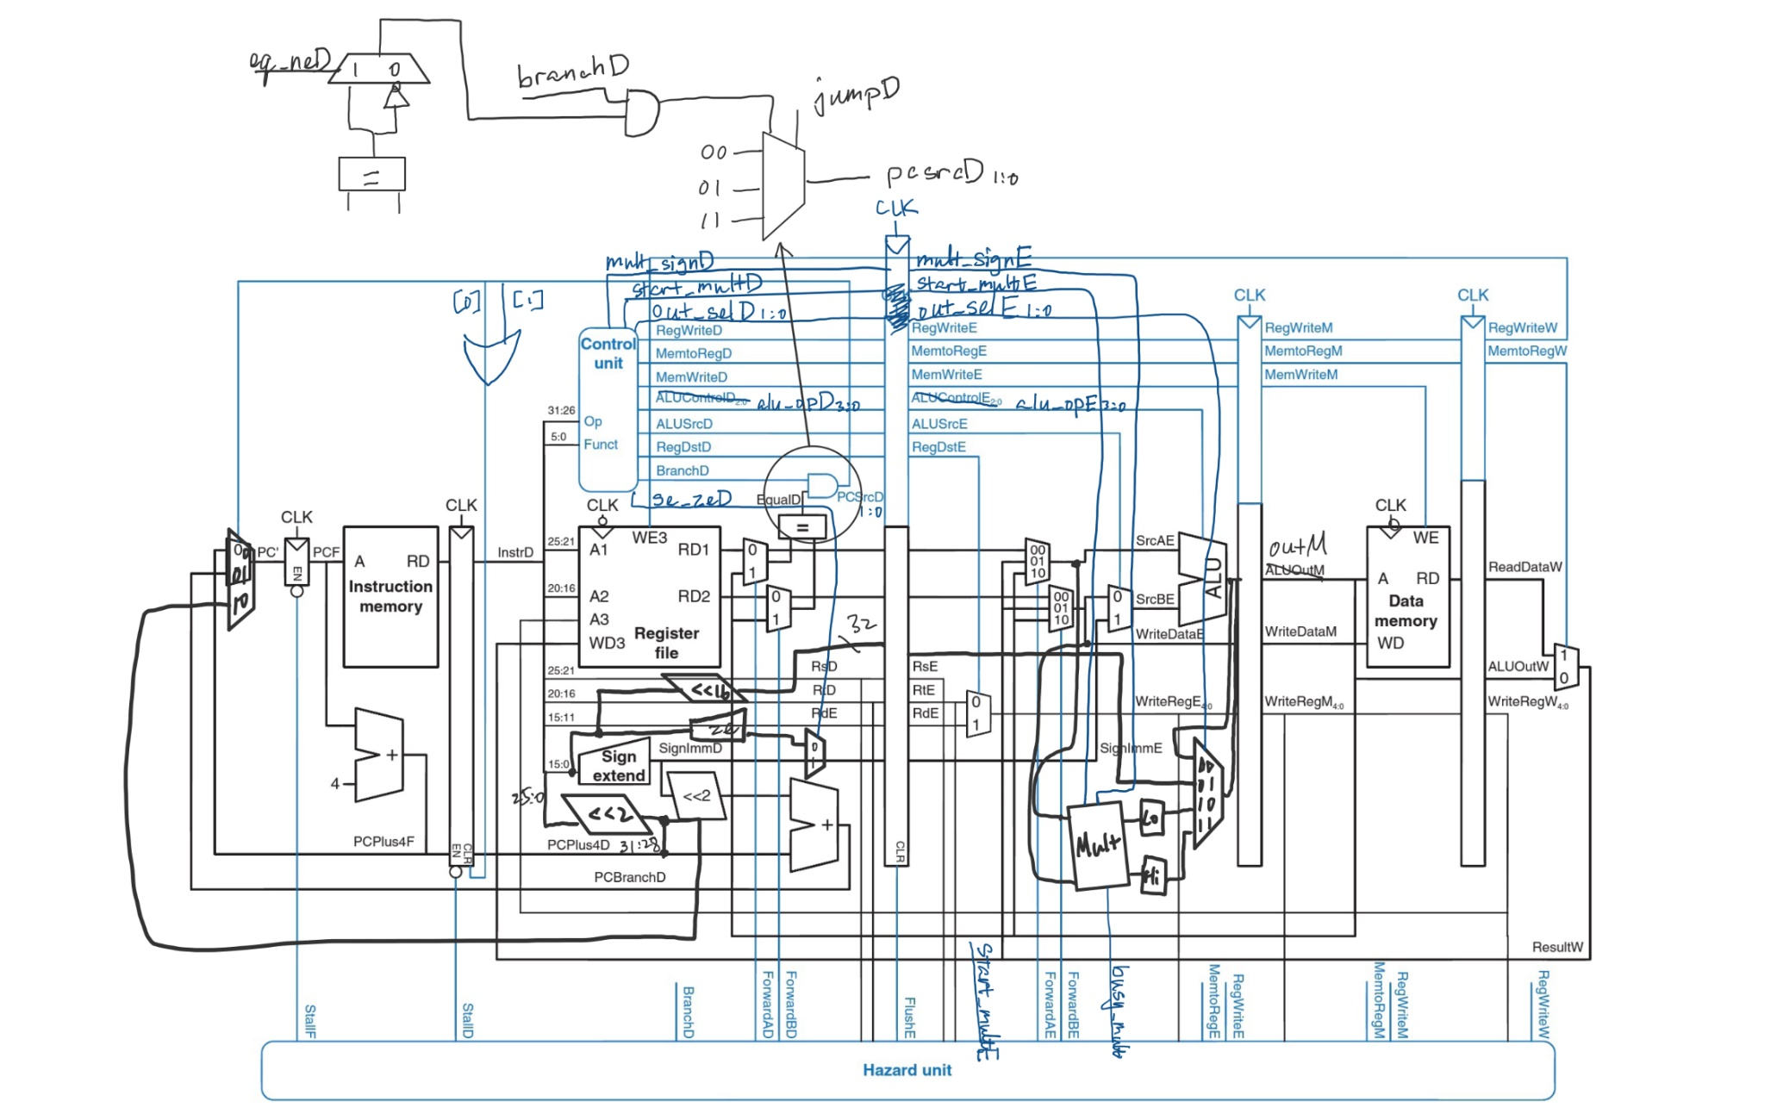

Hazard detector / Forwarding unit

**Step11:** Finalize the design, connect building blocks using wires.

**Code:**

// top level module

module data_path(input clk, reset);

// fetch stage signals

wire [31:0] pcplus4F, pc_next, pcF;

wire [31:0] instrF;

wire stallF;

// decode stage signals

wire [31:0] instrD;

wire equalD;

wire [4:0] rsD, rtD, rdD;

wire memwriteD, regwriteD, memtoregD, regdstD, alusrcD, se_zeD, branchD, start_multD, mult_signD;

wire [3:0] alu_opD;

wire [1:0] out_selD, pcsrcD;

wire [31:0] readdata1D, readdata2D, muxa_outD, muxb_outD, sh_immD, se_immD, ze_immD, ext_immD, sl2_outD, pcplus4D, pcbranchD, pcjumpD;

wire stallD, forwardaD, forwardbD;

// execute stage signals

wire memwriteE, regwriteE, memtoregE, regdstE, alusrcE, start_multE, mult_signE;

wire [1:0] out_selE;

wire [3:0] alu_opE;

wire [4:0] rsE, rtE, rdE;

wire [4:0] writeregE;

wire [31:0] srcaE, srcbE, aluoutE, readdata1E, readdata2E, writedataE, outE, ext_immE, sh_immE, loE, hiE;

wire flushE;

wire [1:0] forwardaE, forwardbE;

// memory stage signals

wire regwriteM, memtoregM, memwriteM;

wire [4:0] writeregM;

wire [31:0] writedataM, readdataM, outM;

// write-back stage signals

wire regwriteW, memtoregW;

wire [4:0] writeregW;

wire [31:0] outW, readdataW, resultW;

// fetch stage logic

mux3#(32) pc_mux(pcplus4F, pcbranchD, pcjumpD, pcsrcD, pc_next);

register#(32) pc_reg(clk, reset, stallF, pc_next, pcF);

inst_memory imem(pcF, instrF);

assign pcplus4F = pcF + 4;

// decode stage logic

register#(64) pipeline_regD(clk, reset | pcsrcD[0] | pcsrcD[1], stallD, {instrF, pcplus4F}, {instrD, pcplus4D});

controller control(instrD[31:26], instrD[5:0], equalD, memwriteD, regwriteD, memtoregD, regdstD, alusrcD, se_zeD, branchD, start_multD, mult_signD, alu_opD, out_selD, pcsrcD);

reg_file rf(clk, reset, regwriteW, instrD[25:21], instrD[21:16], writeregW, resultW, readdata1D, readdata2D);

assign rsD = instrD[25:21];

assign rtD = instrD[20:16];

assign rdD = instrD[15:11];

mux2#(32) forward_muxaD(readdata1D, outM, forwardaD, muxa_outD);

mux2#(32) forward_muxbD(readdata2D, outM, forwardbD, muxb_outD);

assign equalD = muxa_outD == muxb_outD;

sl16 lui_sh(instrD[15:0], sh_immD);

signext se(instrD[15:0], se_immD);

zeroext ze(instrD[15:0], ze_immD);

mux2#(32) ext_muxD(ze_immD, se_immD, se_zeD, ext_immD);

sl2 jump_sh(se_immD, sl2_outD);

assign pcbranchD = sl2_outD + pcplus4D;

assign pcjumpD = {pcplus4D[31:28], instrD[25:0], 2'b0};

// execute stage logic

wire [155:0] dE, qE;

assign dE = {memwriteD, regwriteD, memtoregD, regdstD, alusrcD, alu_opD, out_selD, start_multD, mult_signD, readdata1D, readdata2D, rsD, rtD, rdD, sh_immD, ext_immD};

assign {memwriteE, regwriteE, memtoregE, regdstE, alusrcE, alu_opE, out_selE, start_multE, mult_signE, readdata1E, readdata2E, rsE, rtE, rdE, sh_immE, ext_immE} = qE;

register#(156) pipeline_regE(clk, reset | flushE, 0, dE, qE);

mux2#(5) regdst_mux(rtE, rdE, regdstE, writeregE);

mux3#(32) forward_muxaE(readdata1E, resultW, outM, forwardaE, srcaE);

mux3#(32) forward_muxbE(readdata2E, resultW, outM, forwardbE, writedataE);

mux2#(32) alusrc_mux(writedataE, ext_immE, alusrcE, srcbE);

ALU alu(srcaE, srcbE, alu_opE, aluoutE);

wire busy_multE;

multiplier mult(clk, start_multE, mult_signE, srcaE, srcbE, busy_multE, {hiE, loE});

mux4#(32) out_muxE(aluoutE, sh_immE, loE, hiE, out_selE, outE);

// memory stage logic

wire [71:0] dM, qM;

assign dM = {memwriteE, regwriteE, memtoregE, outE, writedataE, writeregE};

assign {memwriteM, regwriteM, memtoregM, outM, writedataM, writeregM} = qM;

register#(72) pipeline_regM(clk, reset, 0, dM, qM);

data_memory dmem(clk, memwriteM, outM, writedataM, readdataM);

// write-back stage logic

wire [70:0] dW, qW;

assign dW = {regwriteM, memtoregM, readdataM, outM, writeregM};

assign {regwriteW, memtoregW, readdataW, outW, writeregW} = qW;

register#(71) pipeline_regW(clk, reset, 0, dW, qW);

mux2#(32) memtoreg_muxW(outW, readdataW, memtoregW, resultW);

// hazard detector

hazard_detector hd (branchD,

memtoregE, regwriteE,

memtoregM,

regwriteW,

start_multE, busy_multE, //let hazard unit know when mult is done

rsD, rtD, rsE, rtE,

writeregE, writeregM,

stallF, stallD,

flushE);

// forwarding unit

forwarding_unit fu (regwriteM,

regwriteW,

rsD, rtD, rsE, rtE,

writeregM, writeregW,

forwardaD, forwardbD,

forwardaE, forwardbE);

endmodule

// basic building blocks

module register#(parameter width = 1)

(input clk, reset, en,

input [width - 1:0] d,

output reg [width - 1:0] q);

always @(posedge clk) begin

if(reset)

q <= 0;

else if(~en)

q <= d;

end

endmodule

module mux2#(parameter width = 1)

(input [width - 1:0] d0, d1,

input sel,

output [width - 1:0] y);

assign y = sel ? d1 : d0;

endmodule

module mux3#(parameter width = 1)

(input [width - 1:0] d0, d1, d2,

input [1:0] sel,

output [width - 1:0] y);

assign y = (sel == 2'd0) ? d0 :

(sel == 2'd1) ? d1 :

(sel == 2'd2) ? d2 : {width{1'bx}};

endmodule

module mux4#(parameter width = 1)

(input [width - 1:0] d0, d1, d2, d3,

input [1:0] sel,

output [width - 1:0] y);

assign y = (sel == 2'd0) ? d0 :

(sel == 2'd1) ? d1 :

(sel == 2'd2) ? d2 :

(sel == 2'd3) ? d3 : {width{1'bx}};

endmodule

module signext(input [15:0] a, output [31:0] y);

assign y = {{16{a[15]}}, a};

endmodule

module zeroext(input [15:0] a, output [31:0] y);

assign y = {16'b0, a};

endmodule

module sl2(input [31:0] a, output [31:0] y); // shift left by 2

assign y = {a[29:0], 2'b0};

endmodule

module sl16(input [15:0] a, output [31:0] y); // shift left by 16

assign y = {a, 16'b0};

endmodule

**Step12:** Design a test bench and name it data_path_tb.

**Code:**

`timescale 1ns / 1ns

module data_path_tb;

reg clk;

reg reset = 1;

data_path dut(clk, reset);

initial begin // initialize test

#10; reset = 0;

end

always begin // generate clock to sequence tests

clk = 0; #5;

clk = 1; #5;

end

// 4985

// 12 t4

// check results

/*

always @(negedge clk) begin

if(memwriteM) begin

if(outM === 0 & writedataM === 4985) begin

$display("Simulation succeeded");

#5;

$stop;

end

else begin

$display("Simulation failed");

#5;

$stop;

end

end

end

*/

endmodule

**Questions:**

**1.** Develop a (fancy) program and run it on your MIPS. Show the results. (This should be an interesting program).

**MIPS code:**

addi $s1, $zero, 78 # num = 78

addi $v1, $zero, 0 # sum = 0

addi $t3, $zero, 0 # creat an array

addi $t0, $zero, 1

addi $t1, $zero, 6

while1: sltiu $t2, $t0, 6 # for(i = 1; i < 6; i++) { loop 5 times

beq $t2, $zero, exit1 # sum = sum + num

add $v1, $v1, $s1 # array[i - 1] = sum

sw $v1, myArray($t3) # }

addi $t3, $t3, 4

addi $t0, $t0, 1

j while1

exit1:

addi $t1, $zero, 5 # product = num * 5

mult $s1, $t1

mflo $v1

sw $v1, myArray($t3) # array[5] = product

addi $t0, $zero, 1

addi $t1, $zero, 4

addu $t4, $zero, $t3 # j = 5

addi $t3, $t3, -4 #

while2: slt $t2, $t1, $t0 # for(i = 4; i > 0; i--) { loop 4 times

bne $t2, $zero, exit2 # j++

lw $t9, myArray($t3) # array[j] = array[i] - num

addi $t3, $t3, -4 # }

sub $v1, $t9, $s1

addi $t4, $t4, 4

sw $v1, myArray($t4)

addi $t1, $t1, -1

j while2

exit2:

addiu $t3, $t4, 4

lui $s1, 0xffff

ori $s1, $s1, 0xffff

lui $s2, 0xffff

ori $s2, $s2, 0xffff

multu $s1, $s2 # multiply 0xFFFF_FFFF and 0xFFFF_FFFF

mfhi $t6

mflo $t5

sw $t6, myArray($t3) # array[10] = reghi

addiu $t3, $t3, 4

sw $t5, myArray($t3) # array[11] = reglo

addi $t3, $t3, 4

andi $s2, $s1, 0xffff # array[12] = 0xFFFF_FFFF & 0x0000_FFFF

sw $s2, myArray($t3)

addi $s1, $zero, -1

ori $s2, $zero, 0xff00

subu $v1, $s1, $s2 # diff = 0xFFFF_FFFF - 0x0000_FF00

addi $t3, $t3, 4

sw $v1, myArray($t3) # array[13] = diff

addi $s1, $zero, 100

addi $s2, $zero, -100

sltu $t2, $s2, $s1 # x = (-100 < 100)

addi $t3, $t3, 4

sw $t2, myArray($t3) # array[14] = x

sltu $t2, $s1, $s2 # x = (2'complement of -100 < 100)

addi $t3, $t3, 4

sw $t2, myArray($t3) # array[15] = x

lui $s1, 0xff00

ori $s1, $s1, 0xff00 # x = 0xFF00_FF00

ori $s2, $zero, 0xffff # y = 0x0000_FFFF

and $v1, $s1, $s2

addi $t3, $t3, 4 # z = x & y

sw $v1, myArray($t3) # array[16] = z

or $v1, $s1, $s2 # z = x | y

addi $t3, $t3, 4

sw $v1, myArray($t3) # array[17] = z

xor $v1, $s1, $s2 # z = x xor y

addi $t3, $t3, 4

sw $v1, myArray($t3) # array[18] = z

xori $v1, $s1, 0xffff # z = x xor 0x0000_FFFF

addi $t3, $t3, 4

sw $v1, myArray($t3) # array[19] = z

xnor $v1, $s1, $s2 # z = x xnor y

addi $t3, $t3, 4

sw $v1, myArray($t3) # array[20] = z

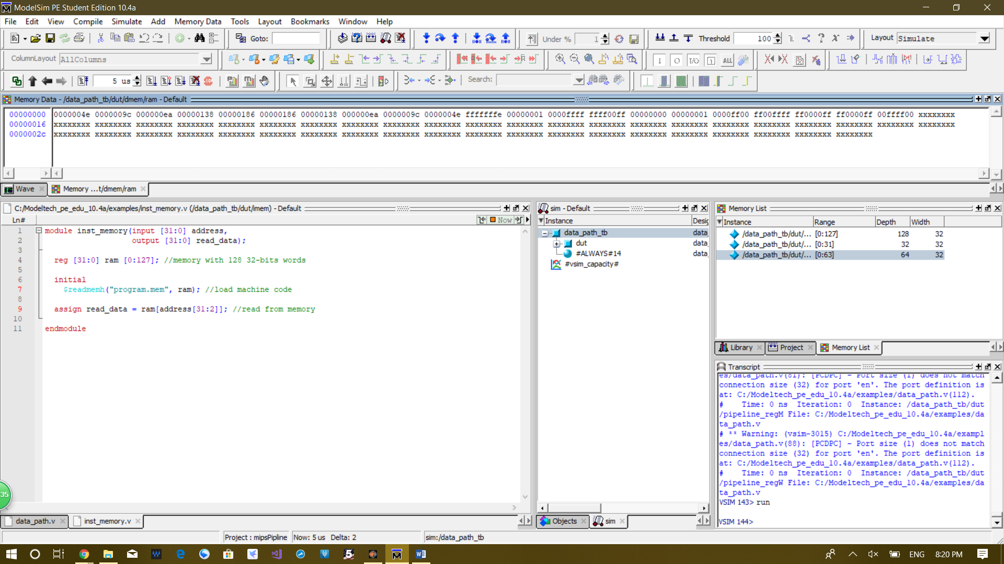

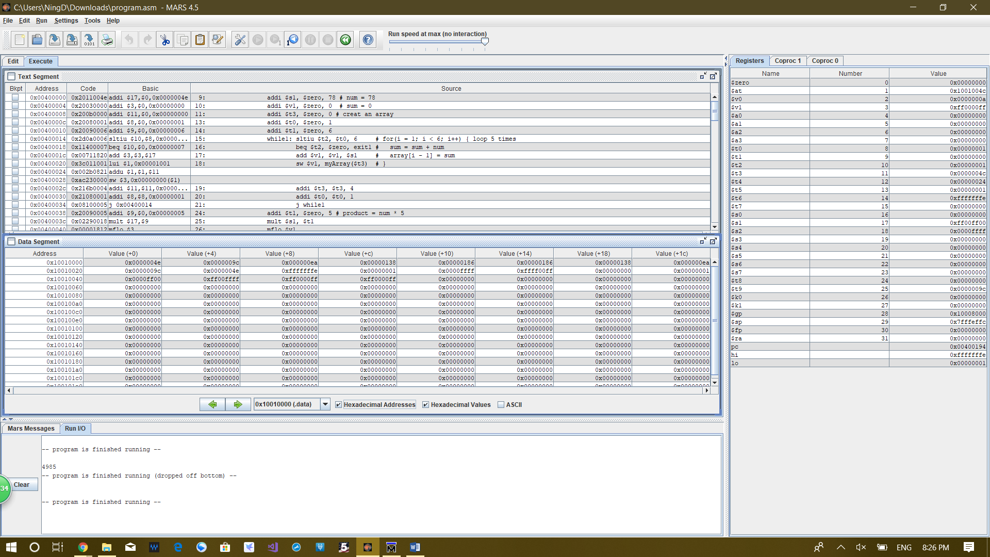Data memory content after running the program

Same program similated in Mars. As you can see they have the same memory content.

Last instruction is xnor, which is not a standard MIPS instruction, so ModelSim data memory have one extra word at the end of the array which store the result of xnor.

**2.** To test your processor, find the dot product of the following vectors:

V1 = [28, 110, −41, 23, −67 ], V2 = [−240, 91, −101, 150, 88], Y = V1.V2T

**MIPS code:**

addi $t1, $zero, 28

addi $t2, $zero, -240

mult $t1, $t2

mflo $t4

addi $t1, $zero, 110

addi $t2, $zero, 91

mult $t1, $t2

mflo $t3

add $t4, $t4, $t3

addi $t1, $zero, -41

addi $t2, $zero, -101

mult $t1, $t2

mflo $t3

add $t4, $t4, $t3

addi $t1, $zero, 23

addi $t2, $zero, 150

mult $t1, $t2

mflo $t3

add $t4, $t4, $t3

addi $t1, $zero, -67

addi $t2, $zero, 88

mult $t1, $t2

mflo $t3

add $t4, $t4, $t3

sw $t4, myArray($zero)

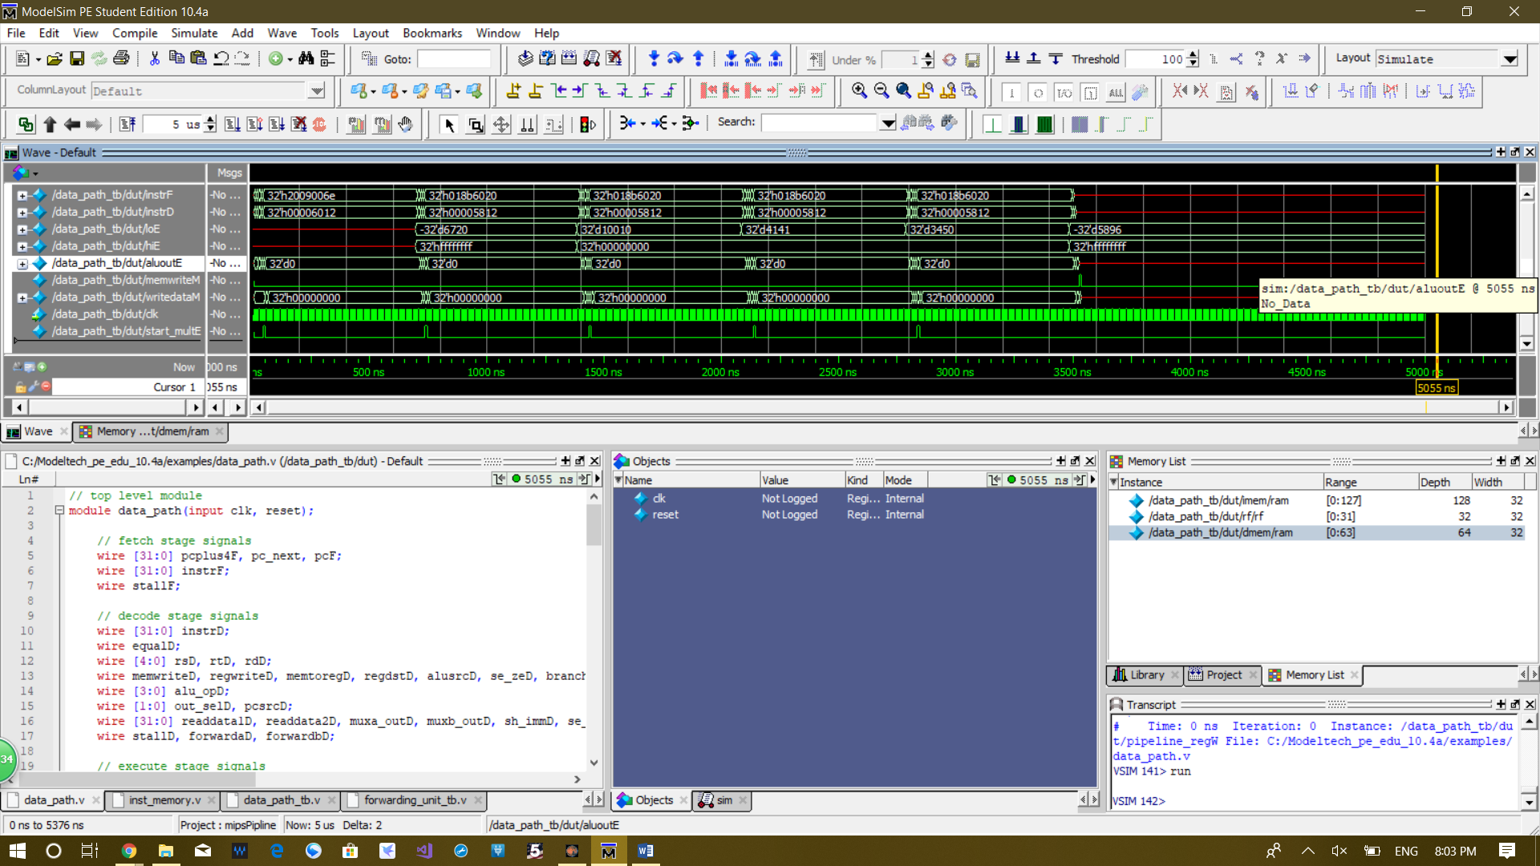**Waveform:**

As you can seen first time loE become valid the value is -6720 which is 28 * -240, next it changes to 10010 which is 110 * 91, next it changes to 4141 which is -41 * -101, next it changes to 3450, which is 23 * 150, next it changes to -5896 which is -67 * 88.

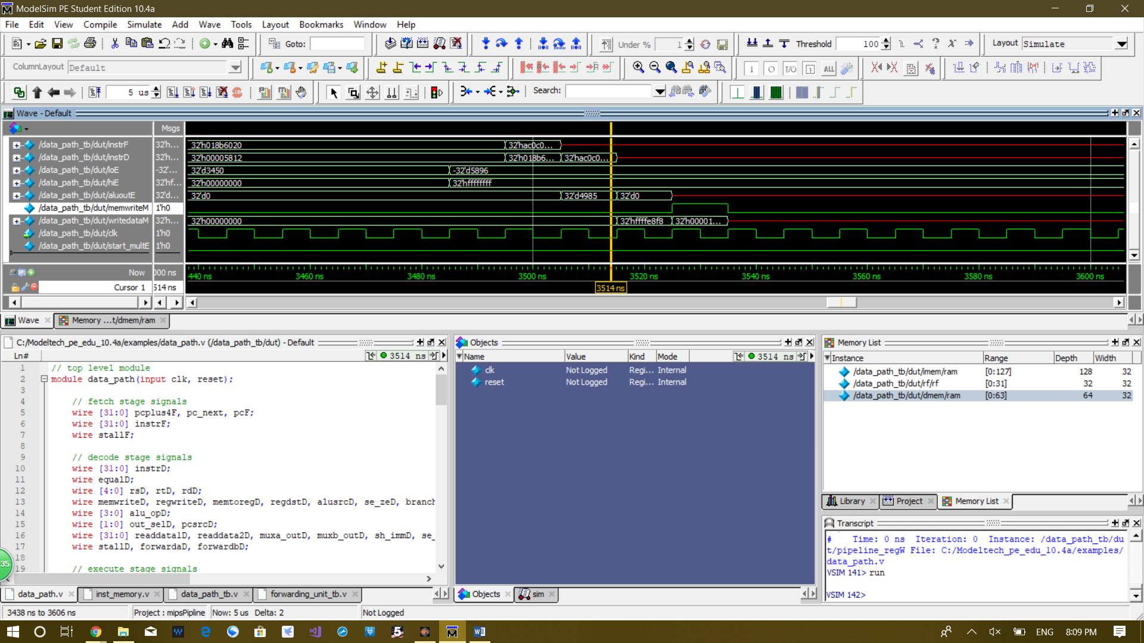

The result of multipling all these numbers up is added and stored to memory. As you can see sum 4985 is stored to memory at the last cycle of the program.

**How many cycles does it take to finish this operation?**353 cycles

**Many hours you have spent on this lab?**

At least 45 hours

**What is your common mistakes in Verilog coding and lessons you learned?**

If conditions are executed concurrently

**Conclusion:**

In this project, we made a 32-bit 5-stage pipeline MIPS. We added may instruction that are not in the MIPS on the text book, including mul, mulu, mflo, mfhi, sltu, xnor, etc. The MIPS we construction is capable of more complex instruction and commands that are not avaible on the version of MIPS on the text book.